Name : Syahira Binti Sulaiman 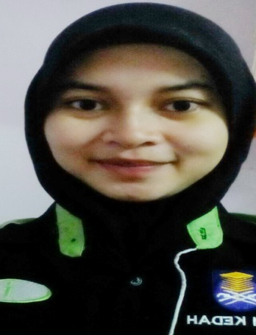

NCIC/ Age : 920825-08-5080/23 years old

Gender / Marital Status : Female / Single

Address : No . 8 . Kampung Sungai Ramai , 32400 , Ayer tawar .Perak .

Contact No : 019 – 4944517 @

Email : syahira_ cyra@ yahoo.com

Expected salary : Rm 2500

**Education**

2009 - 2015

Name of Institution : Universiti Teknologi Mara ( UITM )

: Bachelor Of Business Administration With Honours ( Islamic Banking)

CGPA ( SEM 6) : 2.82

GPA (SEM 6) : 3.00

Graduate at : 22 May 2015 ( waiting for certificated and convocation at June 2016)

(2002 -2007)

: Sekolah Menengah Kebangsaan Ambrose , Ayer Tawar

: STPM - 2B2C

: MUET – Band 3

: SPM – 1A3B2C2E

: PMR - 6B3C

: Sekolah Kebangsaan Sungai Ramai

: UPSR - 3A2B

**Relevant Skills**

* Able to writing , reading and speaking moderately in Bahasa Melayu and English
* Computer Literacy ( Microsoft Word , Access , Power Point and Excel )
* Able to work independently and in –teams
* Able to work under pressure , long hours and long time

**Experience**

* Internship in Takaful company MAA takaful as Takaful Consultant
* Cashier in Halaz enterprise in Ayer Tawar

**Extracurricular Activities :**

2012-2014 (At the University):

* Participant in ‘Program Islamic Talk’.
* Involve in ‘Program Sinar Tanjung Dawai’.

2010-2011 (In School)

* Joined as committee in ‘Pembimbing Rakan Sebaya’.
* Joined a debate competition for upper six.
* Be a Cooperation Prefect.
* Participant in ‘Forum Pembangunan Belia Abad Ke-21’.
* Joined Badminton match as a secretary.
* Joined ‘Persatuan Kadet Bersatu Malaysia (PKBML)’

2005-2009 (In School)

* Become Prefect for Sek. Men. Keb. Ambrose
* Joined ‘Persatuan Kadet Bersatu Malaysia (PKBML)’ as Secretary.

References

HASMAH LAILI BINTI JAMALURUS, 019 - 5909084

Industrial Training Coordinator,

Bachelor of Business Adminstration (Honours) Islamic Banking,

Faculty of Business Management,

UiTM Kedah.